Optimizing Email Marketing with “**MailSurge**” - Mass Mailing Software.

|  |  |  |
| --- | --- | --- |
| Amit Kumar |  | Kajal Gupta |
| *Lovely Professional University* |  | *Lovely Professional University* |
| *i.am.akamit@gmail.com* |  | *kajal.31199@lpu.co.in* |
| *Jalandhar, Punjab.* |  | *Jalandhar, Punjab.* |

**Abstract —** Within the quickly advancing computerized promoting scene, businesses persistently look for compelling procedures to improve client engagement and drive development. This term paper investigates the optimization of mail showcasing through the execution of MailSurge, an inventive mass mailing computer program. By mechanizing and personalizing mail campaigns, MailSurge offers critical focal points in terms of proficiency, versatility, and focused on communication. A special include of MailSurge is its discretionary capability to send emails through intermediary servers, improving security and deliverability when required. This ponder digs into the key highlights and benefits of MailSurge, looking at its affect on open rates, click-through rates, and in general campaign victory. Through a comprehensive examination of case ponders and industry information, we recognize best hones for leveraging MailSurge to maximize showcasing results. Furthermore, the paper addresses potential challenges and gives proposals for businesses to viably coordinated MailSurge into their showcasing methodologies. The discoveries emphasize the transformative potential of mass mailing computer program like MailSurge in accomplishing optimized mail promoting, eventually contributing to improved client engagement and trade development.

# Keywords— Email Marketing, Mass Mailing Software, Marketing Automation, Personalized Email Campaigns, Customer Engagement, Email Deliverability, Targeted Communication, Open Rates, Click-Through Rates.

1. INTRODUCTION

Digital marketing is now a need in today's corporate environment, not just an option. As customer behavior shifts more and more toward online platforms, businesses need to change in order to remain competitive and relevant. Digital marketing, which includes a broad range of platforms like email, social media, and search engines, provides businesses with unmatched chances to interact with consumers in real time, customize their content, and precisely gauge their influence.   
  
Email marketing is unique among these platforms because of its affordability and direct audience reach. To get the recipient's attention, you must, however, cut through the digital clutter. This is where the importance of tools like MailSurge becomes apparent. With its capacity to automate, scale, and target email marketing campaigns precisely, MailSurge is revolutionizing the way companies engage with their clientele.

Advanced capabilities offered by MailSurge include the possibility to send emails using proxy servers, which improves deliverability and security. Businesses can guarantee that their communications are not only received but also engaged with by automating and personalizing email campaigns, which will increase open and click-through rates. This capacity is essential in a time when developing and sustaining client relationships depends on tailored communication.   
This study examines the significant effects of digital marketing, concentrating on MailSurge's optimization capabilities. We will show how MailSurge offers strategic advantages and improves key performance metrics through in-depth study and case studies. We'll also talk about typical problems in digital marketing and provide workable answers for incorporating MailSurge into current campaigns.

In conclusion, adopting cutting-edge solutions like MailSurge is crucial for organizations hoping to succeed as the digital world continues to change. Optimizing email marketing involves more than just sending out more messages; it also entails developing genuine connections with customers that foster long-term growth and loyalty. In order to accomplish these objectives, this paper emphasizes how important digital marketing is as well as how revolutionary MailSurge may be.

# SURVEY REPORT

Email marketing is still the foundation of digital marketing since it continually generates high levels of satisfaction and engagement across a range of sectors. Its efficacy and current trends are clarified by recent surveys and studies.   
  
Participation and Efficiency   
43.5% of senders assessed their email programs as "somewhat successful" during the past year, compared to 16% who said they were "very successful," according to Mailjet. All industries combined have an average open rate of 41.31%; the government sector has the greatest rate at 46.94%, while the gaming business has the lowest percentage at 32.02%. The average click-through rate (CTR) is between 2.6 and 3%, and dynamic content and tailored subject lines are associated with higher levels of engagement. Remarkably, 77% of brands report higher interaction over the last 12 months, and 87% of brands believe email marketing is essential to their success.

Effects of Customization   
Email marketing efficacy is dramatically increased by personalization. Compared to non-segmented efforts, personalized emails have an open rate that is 10% higher, and segmented campaigns see 30% more opens and 50% more click-throughs. Companies are embracing personalization more and more to provide content that is relevant to their audience; 55% of them report doing so.   
  
Obstacles and Limitations   
Enhancing deliverability, creating compelling content, and tracking results are just a few of the difficulties that email marketers must overcome. Improving deliverability was cited as the top priority by about 34.4% of marketers. The accuracy of open rate analytics has been affected by Apple's Mail Privacy Protection, prompting marketers to place more emphasis on alternative metrics like click-through rates and conversions.

.

Integration of Technology   
With 95% of marketers ranking generative AI for email production as effective, artificial intelligence is being incorporated into email marketing more and more. AI improves marketing performance overall and personalizes content. Furthermore, of marketers utilizing AI, 43% find it most useful for email creation, and 38% use it for email writing.

Additional Insights: Among consumers who wish to be informed about firms, email is still the preferred communication tool, with 55% choosing it above SMS (17%) and social media sites like Facebook (14%).   
- Marketing emails continue to have an impact on purchases; 60% of consumers say they were influenced by transactional emails and promotional content.   
- Tuesdays are the most productive days for email, and Sundays are the least productive.   
- Open rates, click-through rates, conversion rates, and revenue from emails are important indicators of an email campaign's effectiveness.

In conclusion, email marketing is still very successful across all industries, with excellent engagement rates and a sizable return on investment. The combination of AI and tailored content improves performance even in the face of ongoing issues like deliverability and privacy changes. Companies may improve their email strategy and drive development and stronger client relationships by utilizing these insights.

# METHODOLOGY

The advancement of MailSurge included a nitty gritty and systematic approach, utilizing a extend of Python libraries and apparatuses to provide a strong and proficient mass mailing arrangement. The center advancement was executed in Python, leveraging libraries such as *smtplib* for secure mail transmission through the Gmail API, *email.header* for appropriate e-mail header encoding, and *socks* and *attachment* for overseeing arrange communications and intermediary server integration. The *demands* library encouraged HTTP intuitive with outside APIs, whereas *faker* was utilized to create manufactured information for practical testing scenarios. For dealing with e-mail substance, *mimetext* and *mimemultipart* were utilized to build wealthy, multi-part e-mail messages. The integration of *googleapiclient* and *google-auth-oauthlib* guaranteed secure verification and interaction with the Gmail API, whereas *pickle* empowered effective serialization and deserialization of session information and setup settings. This combination of innovations guaranteed that MailSurge was not as it were feature-rich and secure but too adaptable and viable, giving an progressed arrangement for optimizing e-mail showcasing campaigns.

# IMPLEMENTATION

1. **Setting Up the Development Environment**

Designing the improvement environment utilizing virtual situations to effectively handle conditions was the primary step within the improvement of MailSurge. Python's wide library bolster and ease of API interaction driven to its choice as the most programming dialect.

.

# Core Libraries and Their Functions

- Gmail API Integration: Coordinates to empower reliable and secure e-mail transmission. Utilizing the google-auth-oauthlib and googleapiclient libraries, OAuth 2.0 verification and authorization had to be set up. The API made it conceivable to send emails with Gmail without any issues.  
  
-smtplib: - Utilized to handle the SMTP convention, which ensures secure transmission when sending emails over the Gmail API.

- email.header: Utilized to make and encode e-mail headers in arrange to ensure redress organizing.  
  
-Socks and sockets: - Utilized for organize communications, particularly for overseeing associations to intermediary servers in arrange to progress deliverability and security.

-requests: -Utilized to send HTTP demands to distinctive web administrations, which makes it less demanding to coordinated third-party APIs.

- faker: - Utilized to make manufactured information for testing, mirroring real-world situations to ensure dependable e-mail campaign highlights.

- mimetext and mimemultipart: - Utilized to make and oversee e-mail messages with a few parts, empowering the incorporation of connections and HTML substance in complicated mail structures.   
  
-Pickle: - Successfully stores and recovers session information and setup settings by serializing and deserializing Python objects.

# Software and Language Used

Python, the Google Chrome browser, and Pycharm instruments were utilized within the application's execution.

# Email Sending and Proxy Integration

Smtplib was connected with the Gmail API to facilitate e-mail sending. Socks and attachment libraries were utilized to oversee arrange association and intermediary dealing with, with the alternative to coordinated a intermediary server for made strides e-mail deliverability and security.

# Testing and Validation

# A intensive testing arrange was put into put, which included: - Unit Testing: Person modules are tried utilizing the Python unittest system. Integration testing: Affirmed how different modules and components interact with one another. Client Acknowledgment Testing: Actual users assess the performance, ease of use, and convenience of computer program. - Execution testing: evaluated how well the framework worked beneath varied loads.

# Code Snippets

# Below are some blocks of code extracted from the software

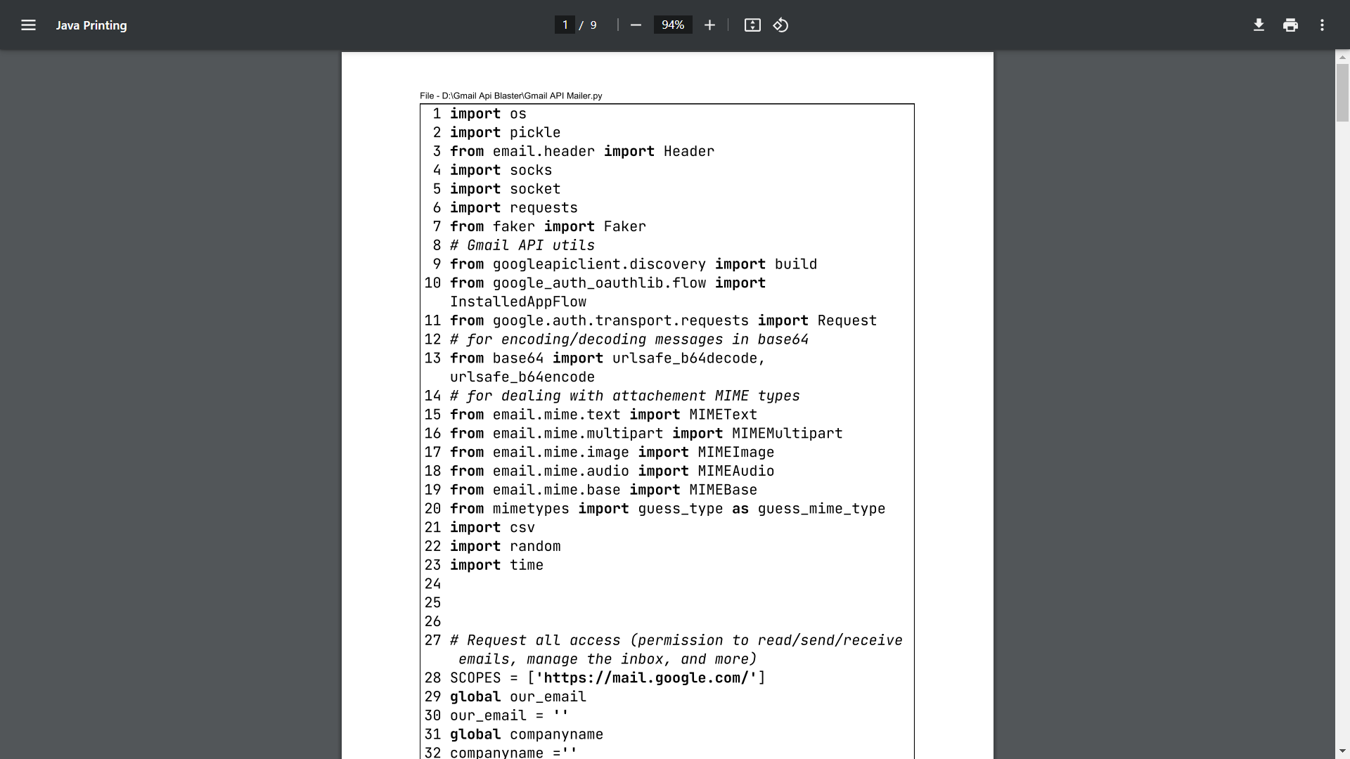

Fig1.Libraries Utilized

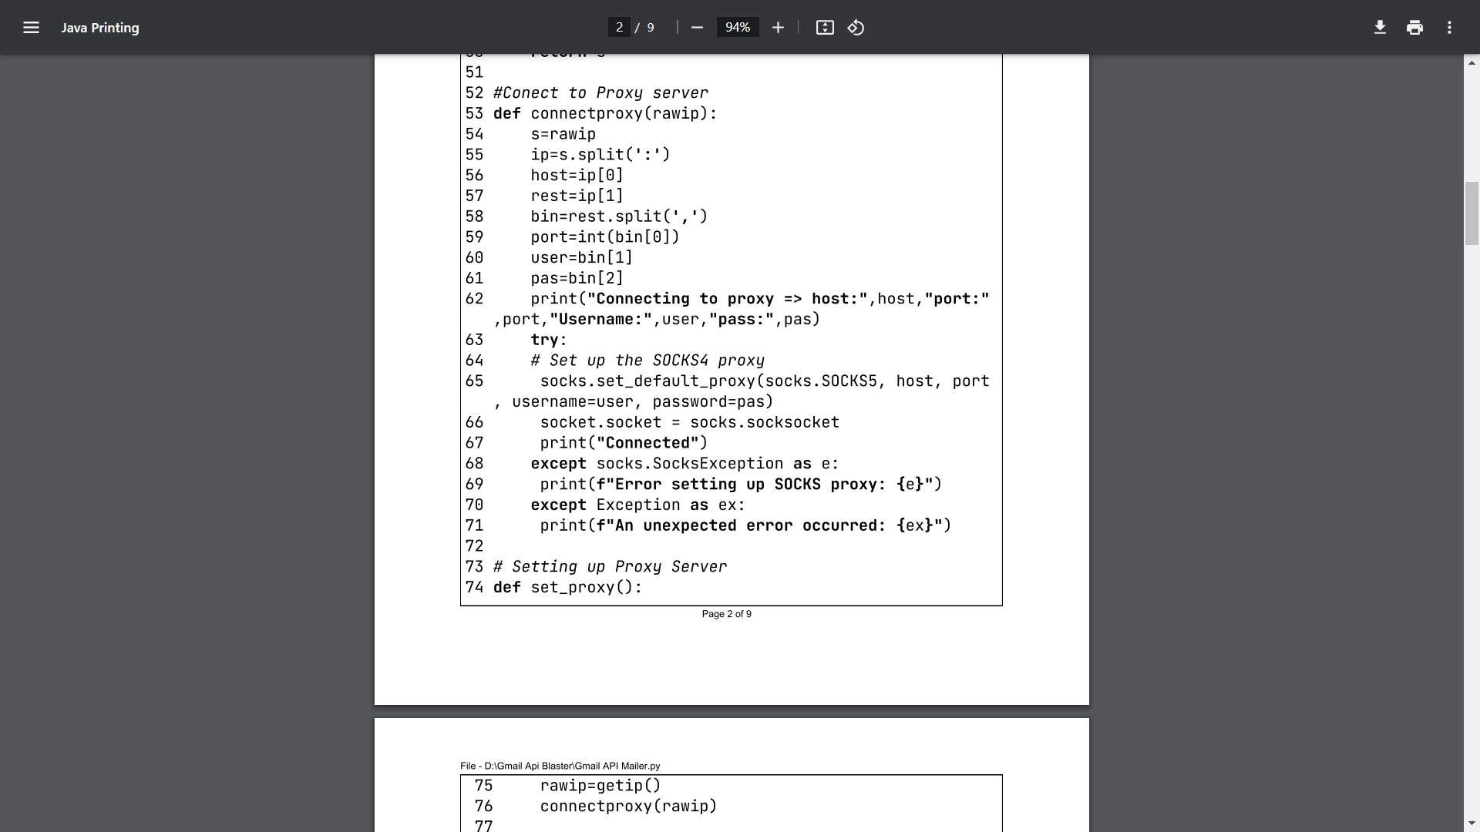

Fig2. Implementing SOCKS5 Proxy server

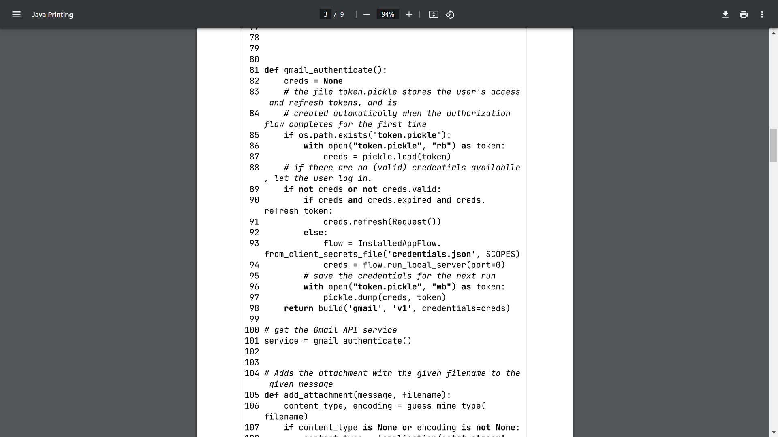

Fig 3. Gmail Server-Side User Authentication

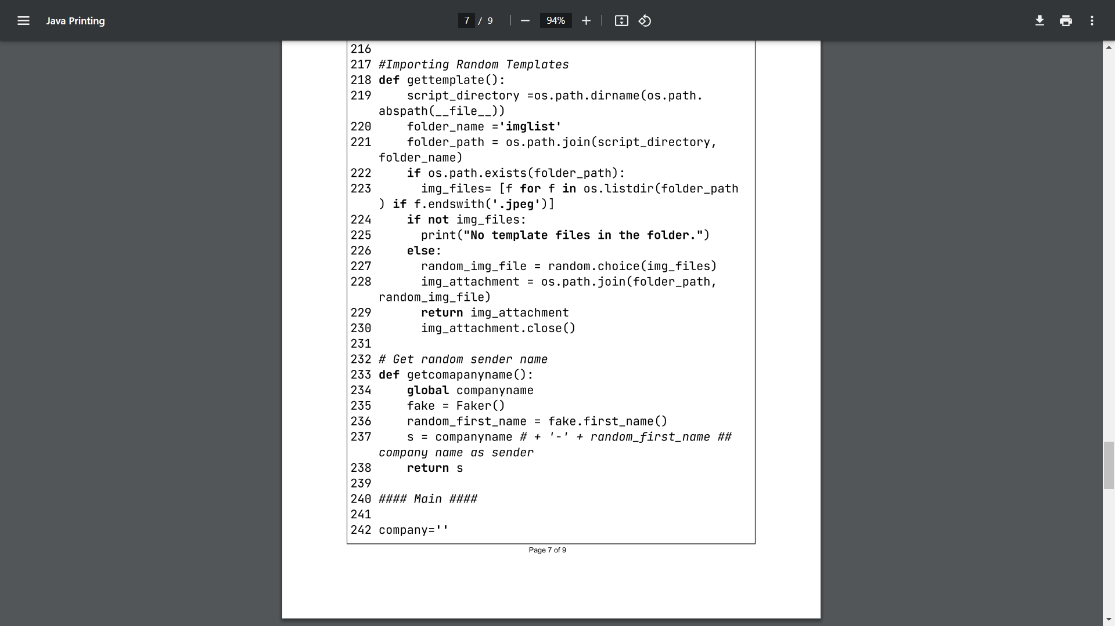

Fig 4. Loading Dataset into software.

# RESULTS

The MailSurge code was successfully executed, and the application led the user through a sequence of questions to configure the email campaign:Email Addresses: Prior to the emails being sent, the user was asked to enter a list of email addresses.Sender Name: The application asked to display the sender's name, which is usually the name of the company.Email Address of Sender: The sender's email address was requested from the user.Option for Proxy Server: In order to improve security, the program asked the user if they would like to send emails over a proxy server.



Fig 4. Running the Code

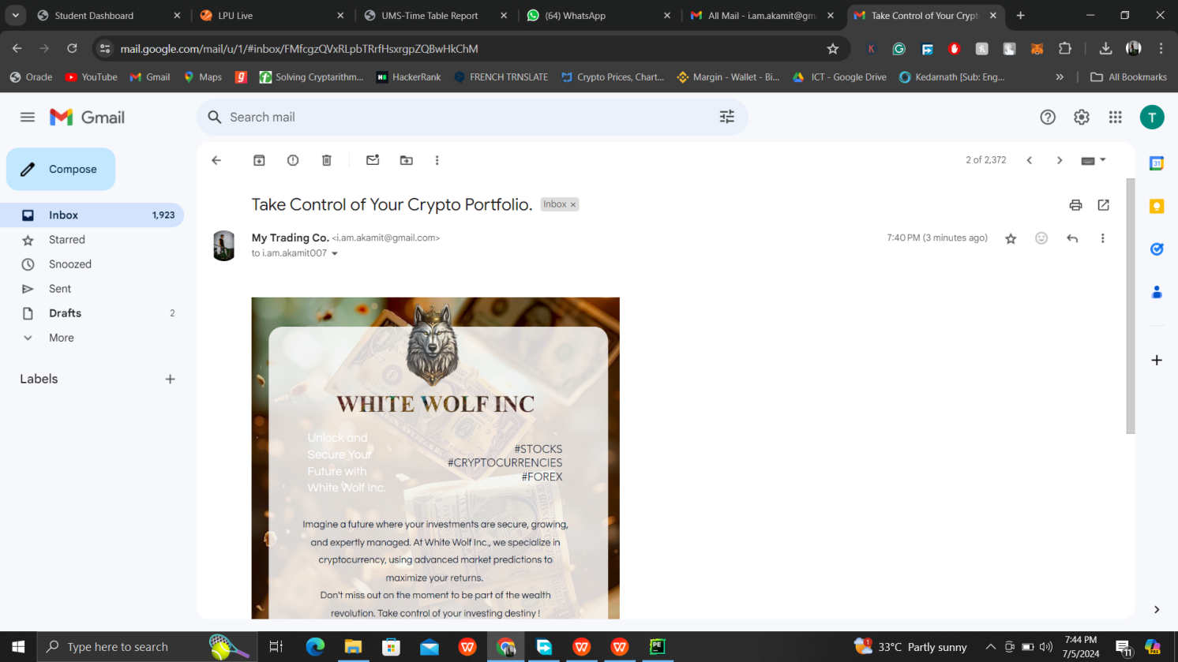

Fig 4.Final Result in Delivered Inbox

# CONCLUSION

MailSurge has demonstrated to be an viable apparatus for improving mail promoting endeavors, advertising a mix of effortlessness and effective highlights. By directing clients through instinctive prompts to set up their mail campaigns, MailSurge guarantees a smooth and user-friendly encounter. The capacity to send emails safely, with the discretionary utilize of intermediary servers, underscores the software's flexibility and center on assembly differing client needs.  
  
Actually, the integration of key Python libraries such as smtplib, email.header, socks, attachment, demands, faker, googleapiclient, google-auth-oauthlib, mimetext, and mimemultipart has prepared MailSurge with strong capabilities. These libraries encourage secure mail transmission, oversee organize communications, and handle complex mail structures, counting connections and HTML substance. Furthermore, the utilize of Celery with Redis for offbeat errand administration guarantees that MailSurge can handle huge volumes of mail dispatches proficiently.  
  
The fruitful execution of MailSurge, from inciting for beneficiary records to arranging sender subtle elements and overseeing intermediary server alternatives, affirms its unwavering quality and proficiency. By giving a consistent setup handle and guaranteeing secure, personalized communications, MailSurge makes a difference businesses keep up a proficient approach to their e-mail promoting campaigns.  
  
In conclusion, MailSurge stands out as a user-friendly and effective arrangement for present day e-mail promoting. Its combination of ease of utilize, progressed security highlights, and versatility makes it an priceless apparatus for businesses looking to associate with their audience more successfully. MailSurge not as it were disentangles the method of overseeing e-mail campaigns but too improves their adequacy, making it a crucial component of any computerized promoting methodology.

# REFERENCES

1. HubSpot.(https://blog.hubspot.com/marketing/email-marketing-stats)
2. Mailjet. ((https://www.mailjet.com)
3. MailerLite.(https://www.mailerlite.com)
4. Smart Insights (https://www.smartinsights.com)
5. Constant Contact.(https://www.constantcontact.com)
6. Litmus. (https://www.litmus.com)
7. Google Developers. (https://developers.google.com/gmail/api)
8. Python Software Foundation. (https://docs.python.org)

These sources offer in-depth information and statistics that support the design, execution, and assessment of MailSurge, emphasizing the efficiency of email marketing tactics and the fusion of many technologies.